City of Moundsville
Comprehensive Plan
2024

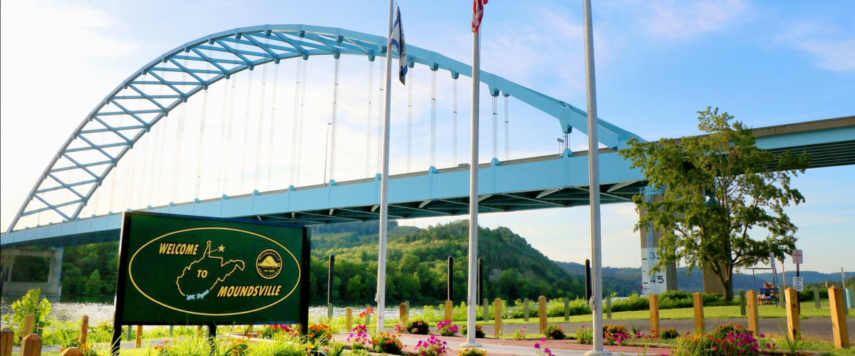

Acknowledgements
The City of Moundsville Comprehensive plan belongs to the community. The plan will help further the goals and objectives of the community. Under the West Virginia Code, the planning commission for a community “shall prepare a comprehensive plan” (§8A-3-3(a)). The Moundsville Planning Commissioners, who are volunteers, have spent countless hours reviewing the 2014 Comprehensive plan drafted with the aid of West Virginia University’s WVU Law: Land Use & Sustainable Development Law Clinic, 2024 plan drafts, identifying issues, working with citizens and business owners, and discussing the future goals and objectives of the city. The support and input of the City of Moundsville staff as well as its elected officials was also invaluable in obtaining information, organizing meetings, and providing the necessary support to complete the comprehensive plan. Moundsville was also fortunate, in 2011, to enlist the services of WVU Public Administration faculty member Margaret Stout, doctoral student Festus Manly-Spain, and students in the Local Governance and Public Engagement and Collaboration courses. Their efforts were instrumental in building capacity, gathering data, and developing the framework of the city’s 2014 comprehensive plan which is the foundation and provides the framework for the 2024 plan.
The initial development of the comprehensive plan proceeded in incremental steps over a two year period (1) generating, discussing, and organizing ideas on obtaining feedback from the community, city, and business stakeholders; (2) mobilizing and unifying those same community stakeholders in meetings and public forums; (3) performing a SWOT (Strengths, Weaknesses, Opportunities, and Threats) analysis on the feedback obtained through traditional surveys, online surveys, and in-person meetings; and (4) constructing the revised Comprehensive Plan Draft to submit to the city. Since this time and while staying in constant communication with City Leaders, employees, and elected officials, the volunteers who serve on the City of Moundsville Planning Commission continued to work on city business while maintaining progress on the Comprehensive Plan Revision Process. The culmination of several months and countless hours of work from the planning commission, citizen planners, city staff as well as information from former contributors, WVU and WVU Extension Service personnel, was the “City of Moundsville Comprehensive Plan 2024” draft. A significant portion of the 2014 City of Moundsville Comprehensive Plan, drafted with the aid of WVU, and the revisions for 2024 draft have been directly incorporated into this comprehensive plan, sometimes verbatim.
All statutory requirements for the comprehensive plan revision have been met. With the assistance of the Law Clinic in 2014 and dedication of the Planning Commission members in 2024, the planning commission held two public forums, provided paper and on-line surveys to the community, developed an action plan and timeline, completed a thorough review of each section of the comprehensive plan, and using the draft as a detailed reference completed a comprehensive plan. A copy of the 2024 draft as well as this comprehensive plan will be available in City Hall for review.

Table of Contents
Chapter 1: Introduction
◻ Plan Organization ...................................................................................................Page 5
◻ Legal Framework .................................................................................................. Page 6
◻ Required Objectives for a Comprehensive Plan ……………………….………...Page 7
◻ Required Components for a Comprehensive Plan………………………………...Page 7

Chapter 2: Community Overview
◻ History ................................................................................................................... Page 8
◻ Population Characteristics ..................................................................................... Pages 9-10
◻ Economic Characteristics ...................................................................................... Pages 11-13
◻ Housing Characteristics ......................................................................................... Pages 13-16
◻ Form of Government ............................................................................................ .Pages 16-19
◻ Transportation Characteristics............................................................................... Pages 20-21
◻ Existing Land Use ................................................................................................ Pages 21-22
Chapter 3: Needs Assessment
◻ Public Participation ...........................................................................…………...Page 23
◻ Vision Statement and Goals ..............................................................…………...Page 24
◻ Governance ...........................................................................................………...Pages 24-25
◻ Land Use ...............................................................................................………...Pages 25-26
◻ Housing ..............................................................................................…...……...Pages 26-27
◻ Economic Development .....................................................................…...……...Page 28
◻ Transportation and Infrastructure ..........................................................…..…...Pages 29-30
◻ Quality of Life ......................................................................................………...Page 30

Chapter 4: Action Plan
◻ Vision Statement and Action Plan Explanation...................................….……...Page 31
◻ Plan Progress and 2014 Goals Review.................................................….……...Page 32
◻ Goal 1--- Promote Financial and Economic Development……………………...Page 33

◻ Goal 2– Plan for Housing Options in Moundsville..............................….….…...Pages 33-34
◻ Goal 3– Plan for Infrastructure Updates…………............................…....……...Page 34
◻ Sources List……………………………………...........................….…………....Page 35
◻ List of Appendices……………………….............................................…....…….Page 35

Appendices
Appendix A-Public Input
Appendix B-SWOT Analysis
Appendix C- Stakeholders List
Appendix D-Commissioners List
Appendix E-Ten Year Plan
Appendix F-Progress Monitoring Data Sheet
Appendix G-City of Moundsville Comprehensive Plan Updates

Chapter 1: Introduction
Moundsville, a city nestled along the
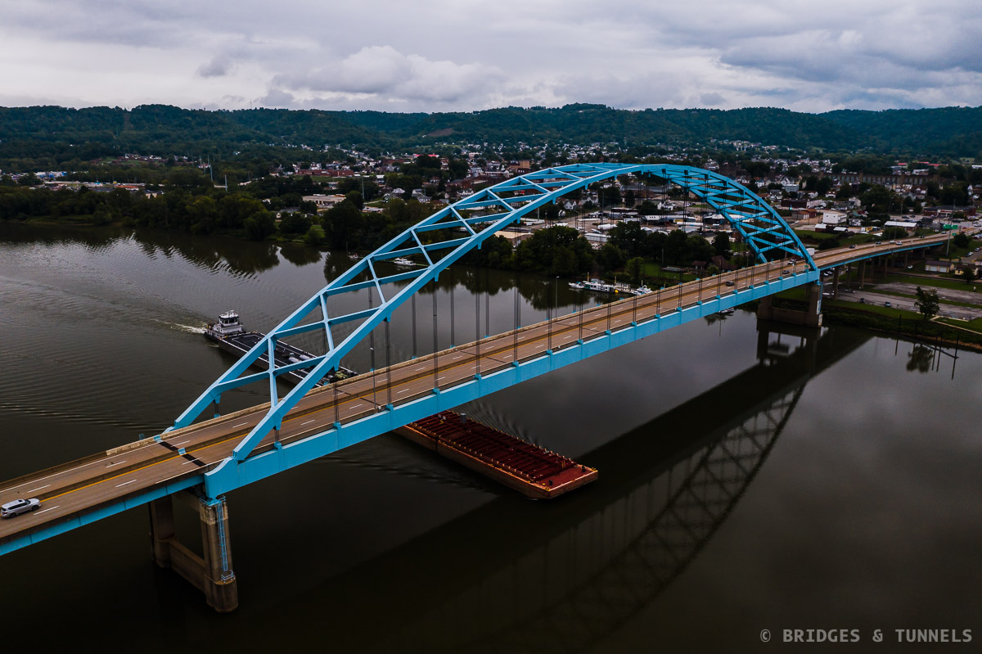
banks of the Ohio River, is deeply rooted
in history going back through antiquity
and the Adena people, to more recently
as the center of trade and commerce for Marshall
County.
Although recent decades have been
challenging, Moundsville now has the opportunity to
revitalize itself, using some of the same qualities and
characteristics that once allowed it become a bustling
industrial city. One of the best ways for Moundsville
to move forward is through the revision of the previously adopted comprehensive plan.
A comprehensive plan is the foundation for a future within a community.
The comprehensive plan for the City of Moundsville is a blueprint, guiding the growth of the
community and providing a “vision” for the City’s future. The Plan will promote coordinated,
orderly, and harmonious development of the City providing guidance for future needs.
Plan Organization
The City of Moundsville Comprehensive Plan is organized into four (4) chapters. In order to facilitate the development of an easy-to-read document, each chapter has a distinct purpose.
Chapter 1 provides the Introduction, which lays out the framework for the rest of the document.
Chapter 2 offers the Community Overview, which gives a historical snapshot of Moundsville, as well as an overview of the City’s current situation with regards to land use, housing, education, economic, transportation, and public facilities.

Chapter 3 sets out the Needs Assessment results, which identifies the issues that need to be addressed in order for the City to achieve its vision of the future.

Chapter 4 articulates the Action Plan, which lists goals, objectives, and specific action steps, prioritized by importance to the community.
◻ Chapter 1- Introduction
◻ Chapter 2- Community Overview
◻ Chapter 3- Needs Assessment
◻ Chapter 4- Action Plan
◻ Appendices
A comprehensive plan must contain the following components:
· Land use
· Housing
· Transportation
· Infrastructure
· Public Services
· Recreation
· Economic development
· Community design
· Preferred development areas
· Renewal and/or redevelopment
· Financing
· Historic preservation
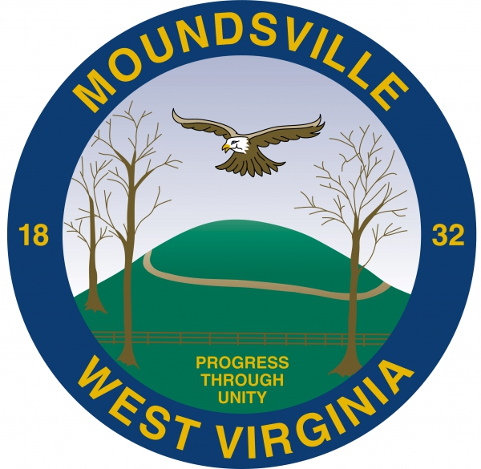

Legal Framework
Chapter 8A of the West Virginia Code establishes the scope and purpose of community
comprehensive plans.
As stated in §8A-1-1(a)(5) “a comprehensive plan is a guide to a community’s goals and objectives and a way to meet those goals and objectives.” According to the West Virginia Code the comprehensive plan should also “be the basis for land development and use, and be reviewed
and updated on a regular basis (§8A-1-1(b)(3)), which the Code later defines as every 10 years
(§8A-3-11(a)).
A comprehensive plan is required if a governing body wants to enact a zoning ordinance, enact a
subdivision and land development ordinance, require plans and plats for land development, or
issue improvement location permits for construction.
Pursuant to Chapter 8A, a comprehensive plan must meet certain objectives and contain certain
components in order to be considered valid. Care has been taken to ensure that all required
objectives and components have been sufficiently addressed in Moundsville’s Comprehensive
Plan.

Required Components for a Comprehensive Plan

W. VA. Code §8A-3-4(c )(1)-(13)

Code Provision Page #

Land Use
Different land uses (including, for example, residential, agricultural, historic, etc.) 2-11, 2-12
Population density and building intensity standards 4-6
Growth and/or decline management 3-5, 4-4
Projected population growth or decline 2-3
Constraints on development (including identifying flood-prone and subsidence areas) 3-6
Housing
Analyze projected housing needs and different types of housing needed (including af-
fordable housing and accessible housing for persons with disabilities) 3-6 through 3-8
Identify the number of projected housing units and land needed 3-6
Address substandard housing 3-7, 4-6, 4-7
Rehabilitate and improve existing housing 4-6, 4-7
Adaptive reuse of buildings into housing 3-7, 4-6, 4-7
Transportation
Vehicular, transit, airport, railroad, river, and any other mode 2-10, 2-11, 3-9, 3-10, 4-11, 4-12
Movement of traffic and parking 3-9, 3-10, 3-11
Pedestrian and bicycle systems 2-10, 4-4, 4-8
Intermodal transportation 3-9
Economic development
Analyze opportunities, strengths and weaknesses 3-8, 3-9
Identify and designate economic development sites and/or sectors 4-8 through 4-10
Identify types of economic development sought 3-8, 4-8, 4-9
Miscellaneous Components
Infrastructure 2-9, 4-11, 4-12
Public Services 2-7 through 2-9
Rural 2-11
Recreation 2-8, 2-9, 4-14
Community Design 3-6, 4-9, 4-10
Preferred development areas 4-8 through 4-10
Renewal and/or redevelopment 3-7, 4-6, 4-8, 4-13
Financing Implementation Matrix
Historic preservation 3-6, 4-9, 4-10

West Virginia Code | §8A-3
https://code.wvlegislature.gov/8A-3/

Chapter 2: Community Overview
History
The City of Moundsville is located in Marshall
County, West Virginia, in the lower portion of the
Northern Panhandle along the Ohio River.
Marshall County was created through the
consolidation of separate parts of Ohio County by
the Virginia General Assembly on March 12, 1835.
The county was named in honor of United States
Supreme Court Chief Justice John Marshall (1755-
1835).
Moundsville’s name derives from a large mound near the center of town. According to the Grave
Creek Mound Archeological Complex, an agency of the West Virginia Division of Culture and
History, the mound was a burial ground for the Native American people that lived in the area
from 1000 to 200 B.C., a time known as the Early Woodland period. At 69 feet in height and
295 feet in diameter, the Grave Creek Mound is the largest conical-type burial mound in the
United States. Unfortunately, much of the archaeological evidence in the structure was
destroyed in 1838 when several non-archaeologists tunneled into the mound.
The area was first settled in 1771 by two European immigrants, Samuel and James Tomlinson.
James Tomlinson named the area “Elizabethtown” after his wife. The community was platted
in 1798 and incorporated in 1830. Nearby, the Town of Mound City was settled by Simon Purdy
and incorporated in 1832. Mound City and Elizabethtown merged in 1866 to form the City of
Moundsville. Later that same year, construction began on another one of the city’s notable
landmarks, the maximum security West Virginia Penitentiary, which would remain in
operation from 1867 until 1995. This facility is now used for historical and community benefit as well as being repurposed for Adult Education Services, Mock Riot Practices, and much more.
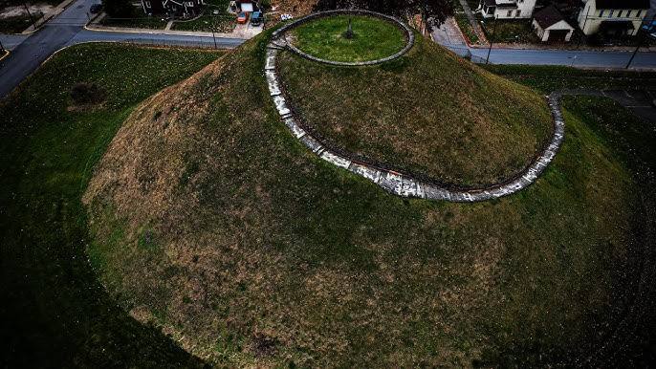
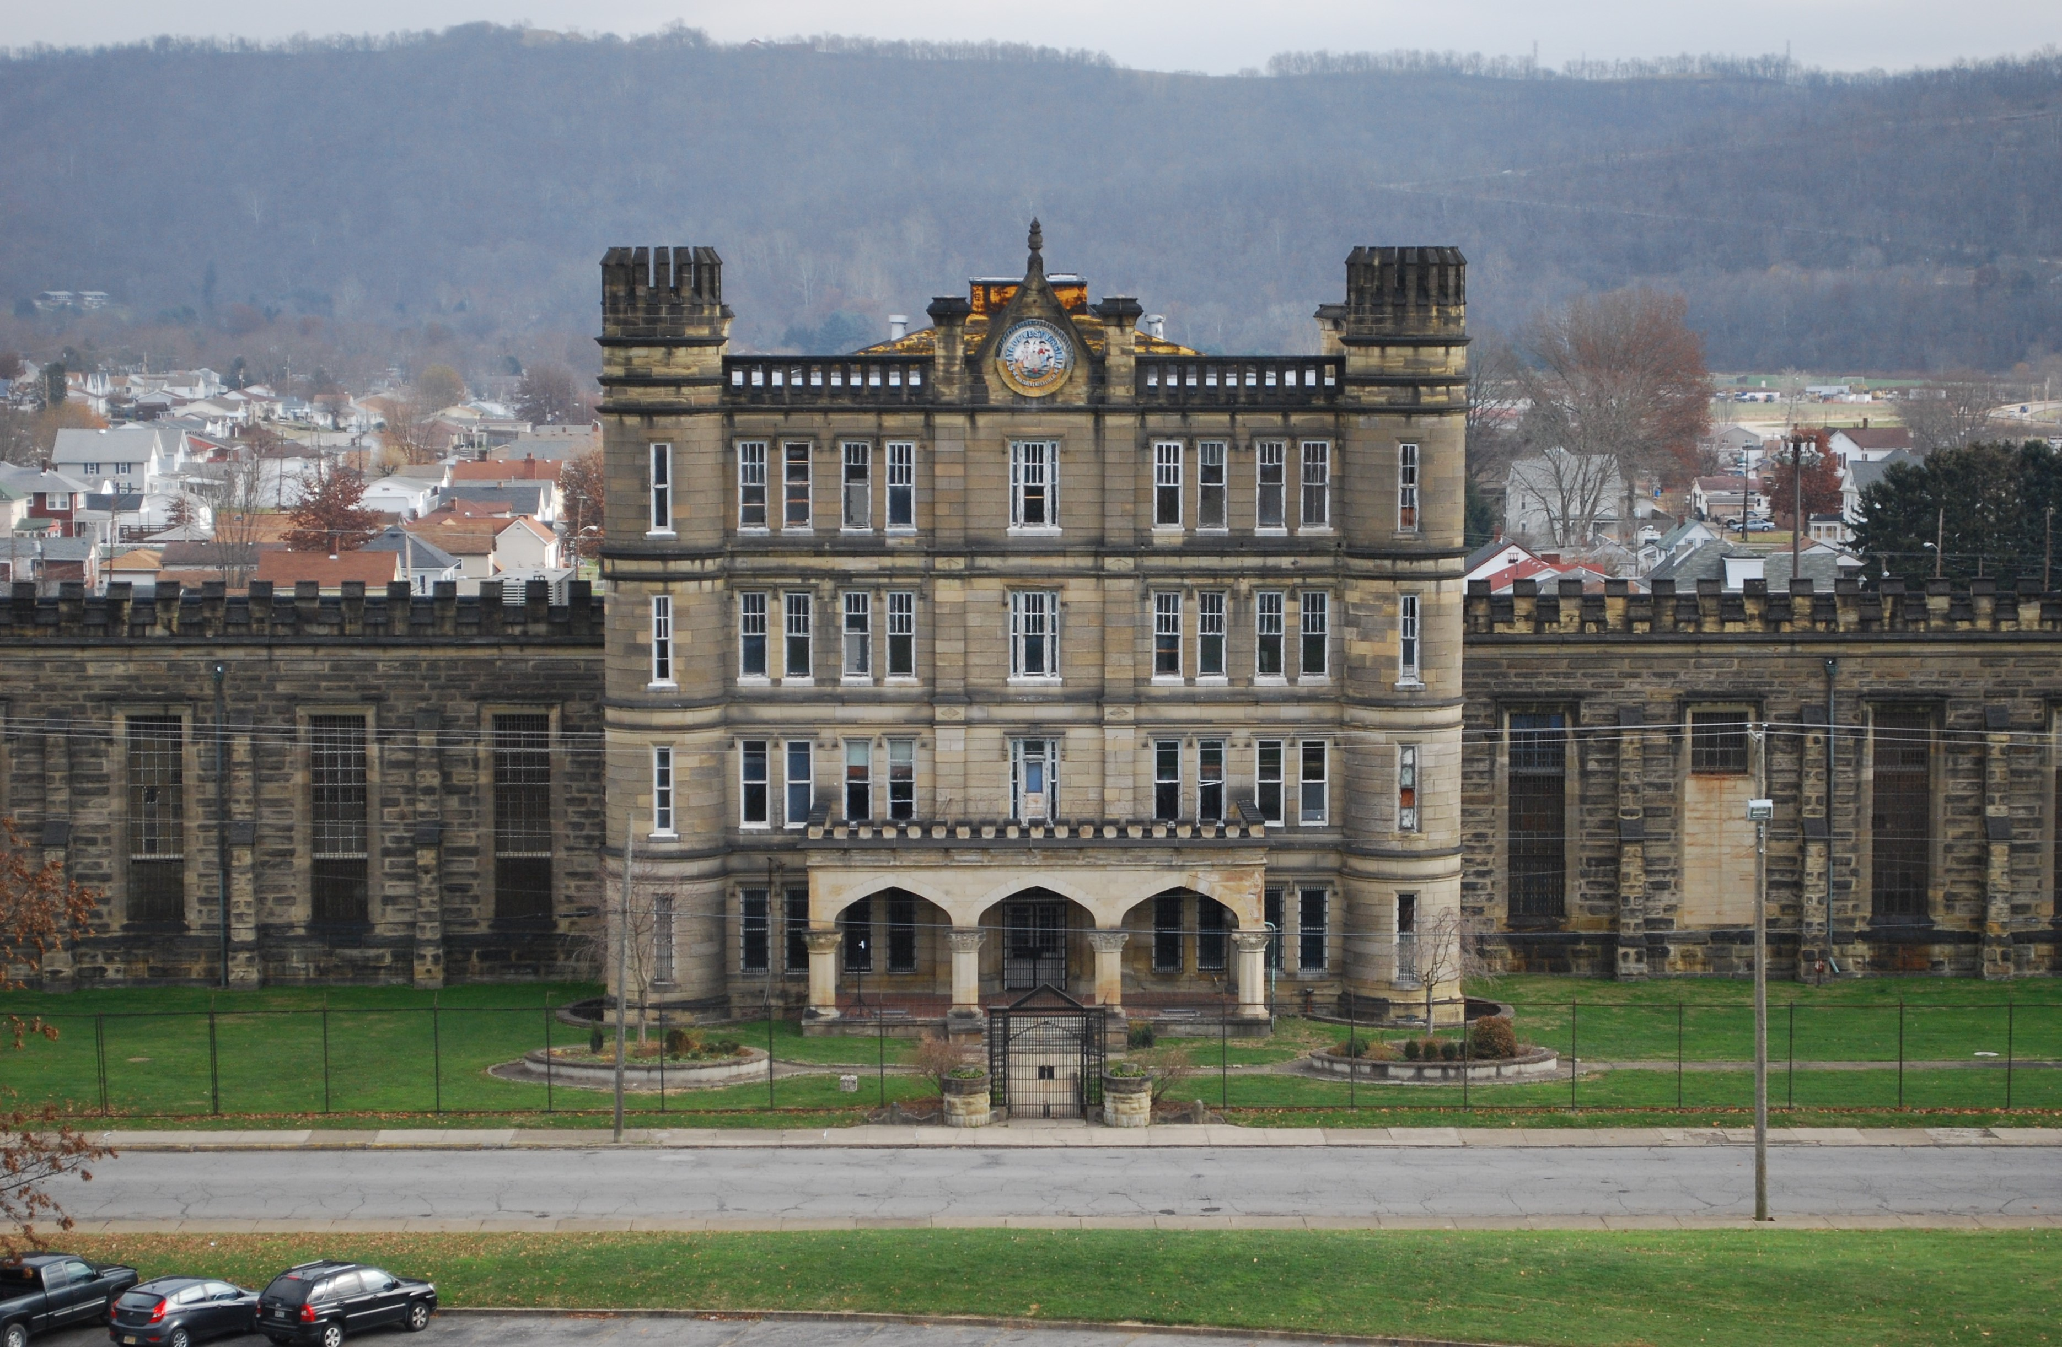
Moundsville’s location in the Northern
Panhandle and along the Ohio River gives it
unique cultural and economic ties to the
large manufacturing and industrial centers
of the Midwest and Northeastern United
States. For example in 1870, Moundsville
ranked third in the state in manufacturing
production.
Moundsville’s local economy was strongly affected by the structural changes that swept the nation’s industrial economy in the late 20th Century, including the effects of low foreign labor costs, increased automation, increased environmental regulations, and new and expanding international trade agreements. Despite these changes, Moundsville has managed to retain much of its industrial character, and its rich economic and cultural history remains not only visible, but a prominent part of the city’s landscape.
Beginning in the 1980s, the community witnessed the loss of several large employers in the
area, including toy manufacturer-Louis Marx and Company, enamelware producer-United
States Stamping Company, Valley Camp Coal Company, AEP-Power’s Kammer Plant and most recently the closing of several retail and grocery establishments including Giant Eagle and Save-a-Lot Supermarkets. Perhaps most notable, however, was the closure of the Fostoria Glass
Company, which was headquartered in the community from 1891 to 1986. At its height, the
hand blown glassworks company produced eight million pieces of glass, employed nearly 1,000
workers, and products were used by U.S. Presidents from Eisenhower through Reagan.
In 1995, the Moundsville Commercial Historic District was established through the National
Register of Historic Places. The district is located along Jefferson Avenue from 2nd to 7th Streets and then follows along 7th street between Jefferson and Lafayette Avenues. The designation provides recognition for the community, while enabling property owners to become eligible for certain tax provisions and apply for
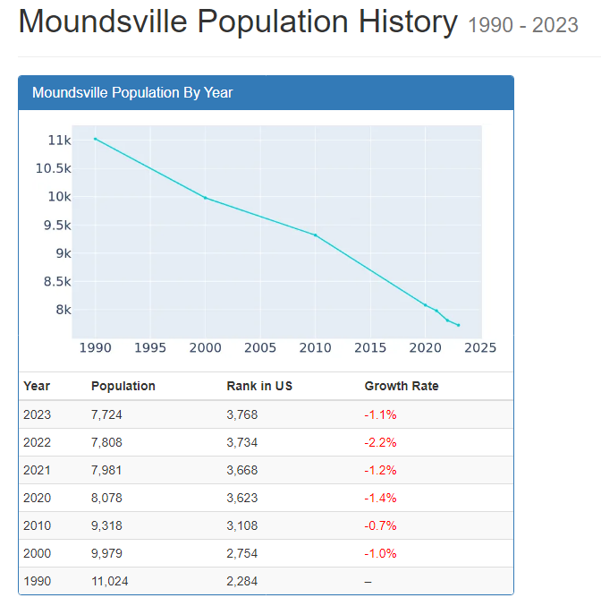
matching grant funds for restoration.
Population Characteristics
Moundsville is part of the Wheeling Metropolitan
Statistical Area (estimated MSA population of
144,637 in 2009). The City’s population peaked in
1960 at 15,163 and has been in decline ever since,
as shown in Chart 1. Between 1960 and 2010,
there was a 38% decrease in the population of
Moundsville. The 2010 Census indicated even further
population loss, with a 1.6 % decrease from
2010 to 2012. The population was 8,122 at the time
of the 2020 census indicating a continued decline
of 1.2% between 2010 and 2020 with an additional 1% decline since the last census.
https://www.biggestuscities.com/city/moundsville-west-virginia)
The loss of population correlates with the loss of industry and presents serious problems for
the municipality, especially in terms of lost tax revenue and human capital. Although
predicting future population change is difficult, as projection models do not account for all
socio-economic circumstances, current trends seem to indicate a further decline in population
for Moundsville. However, with the increased presence of the oil and gas industry, this may not
be the case. There are measures that the city can implement, based on this comprehensive plan, that can mitigate population loss or possibly even facilitate an increase in population for the
first time in several decades. Reinvesting in the city and its residents is a key opportunity here.

The City of Moundsville has embraced its history and heritage while paying homage to its natural resources and many available amenities while formulating plans to reintroduce and reengage citizens within the city. The City of Moundsville has formed an Arts and Culture Commission to help propel the City forward in an endeavor to engage its current, former, and prospective future residents in enjoying and embracing its natural resources including the many elements of the tourism and hospitality industry that the City of Moundsville can provide.
Age Distribution
Compared to West Virginia and the nation as a whole, Moundsville’s population is skewed towards an older demographic. Between 2006 and 2010, twenty-two percent (22%) of the City of Moundsville residents were over the age of 65, compared to 15.8% for West Virginia and 12.7% for the nation. Those numbers continue according to censusreporter.org. 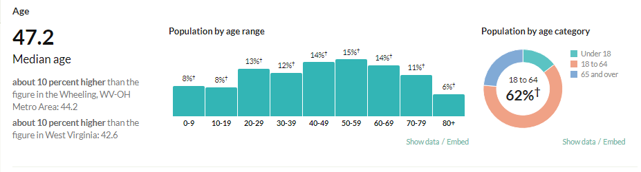

Median Age
According to the 2020 census, the median age in West Virginia is 42.6 years, while the median
age in Moundsville is almost 48 years of age; 2010 numbers were 41 and 43 years of age. 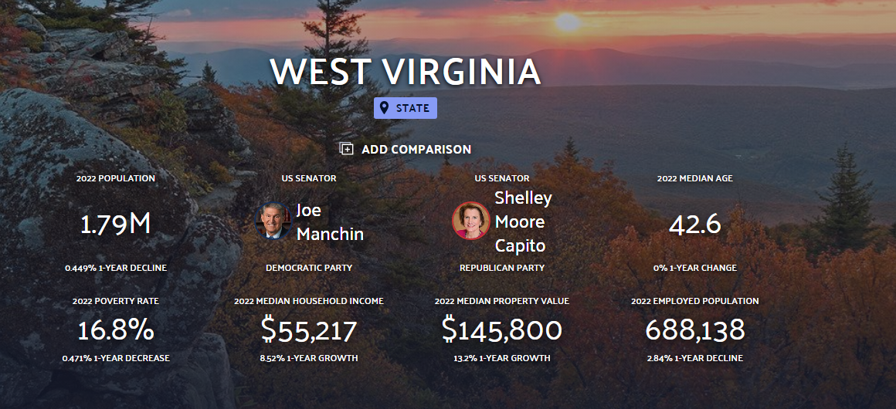

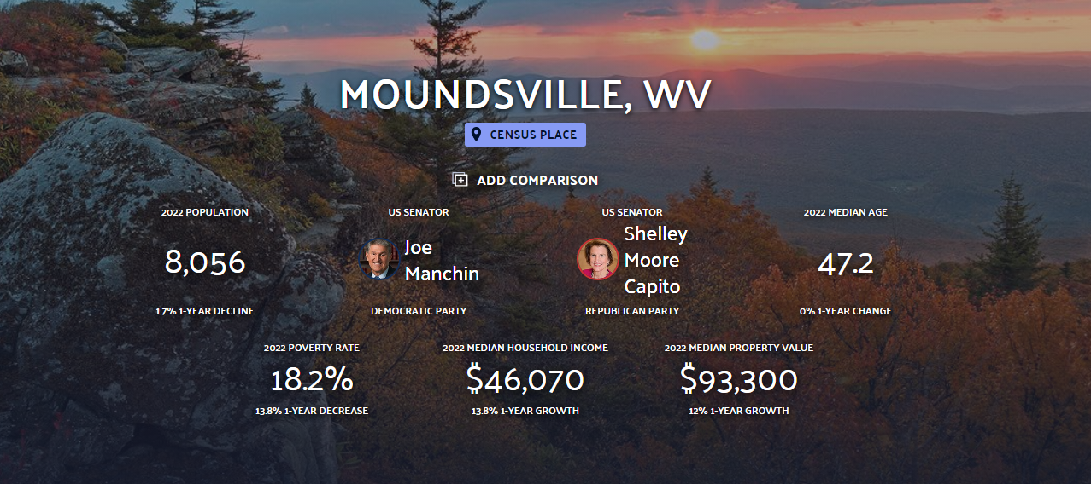
Race

In 2014, the five largest ethnic groups in Moundsville, WV were White (Non-Hispanic) (93.9%), Two+ (Non-Hispanic) (2.15%), Other (Non-Hispanic) (1.85%), Two+ (Hispanic) (1.66%), and Black or African American (Non-Hispanic) (0.161%). According to www.censusreporter.org, these numbers haven’t changed much in 2024. In 2022, Moundsville, WV had a population of 8.06k people with a median age of 47.2, older than in 2014, of this, 46.64% are males and 53.36% are females. US-born citizens make up 97.82% of the resident pool in Moundsville, while non-US-born citizens account for 2.06% with a median household income of $46,070, higher than in 2014. Between 2021 and 2022 the population of Moundsville, WV declined from 8,195 to 8,056, a −1.7% decrease and its median household income grew from $40,471 to $46,070, a 13.8% increase.
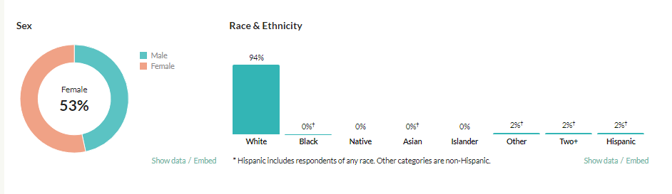
(At the time of the 2020 Census, none of the households in Moundsville, WV reported speaking a non-English language at home as their primary shared language. More recent school data suggests a much more recent change with nine students receiving ELL services living with four families who now report a primary language spoken at home that is not English.)

https://datausa.io/profile/geo/moundsville-wv/
https://boe.mars.k12.wv.us/

Economic Characteristics
Moundsville is the county seat of Marshall County, thereby bringing a host of government jobs to community. This sector employed nearly
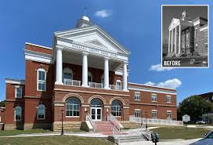
18 percent of the county’s workforce,
with local government representing the largest
share at 12 percent.

With an updated County Court House and
other improvements city wide, Moundsville
Continues to offer a host of public and private
sector employment opportunities.
* Source: United States Census Bureau.

Since 2014, employment in Moundsville has grown at a rate of 6.53%, from 3.29k employees to 3.51k employees in 2022. The most common employment sectors today are Health Care & Social Assistance Fields, Retail Trade, and Accommodation & Food Services.
Employment Status
The unemployment rate in Marshall County was relatively steady from 2000 to 2008. However, from 2008 to 2009, the unemployment rate increased significantly, from 5.0% to 8.7%. The unemployment rate peaked in 2010 at 10.2%; whereas the national unemployment rate in September of 2010, as noted by the Bureau of Labor Statistics was 9.5%. In 2012, the unemployment rate in Marshall County was 8.3%, as compared to the national rate of 7.2% in September of that year. From this data, one can see that Marshall County’s unemployment rate seems to run slightly higher than the national rate. According to homefacts.com, the current unemployment rate for the City of Moundsville is 4.5% as of May 2022 which continues to be commensurate with the unemployment rate for Marshall County which is 5.4%, the rate for WV which is 4.2%, and the national unemployment rate of 4.1%.

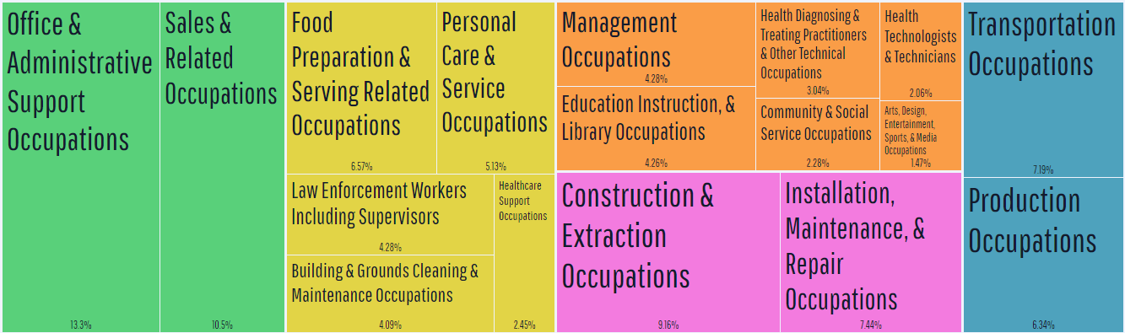
Since the employment stats in 2014 represented in the graph above, the rate of unemployment changed little, but the number of jobs in which people are employed did shuffle with Building & Grounds, Cleaning & Maintenance Occupations growing the most from 4% to 14%. These numbers fluctuate yearly with some categories becoming embedded in others by type and more being created by need as represented in the 2024 graph below.

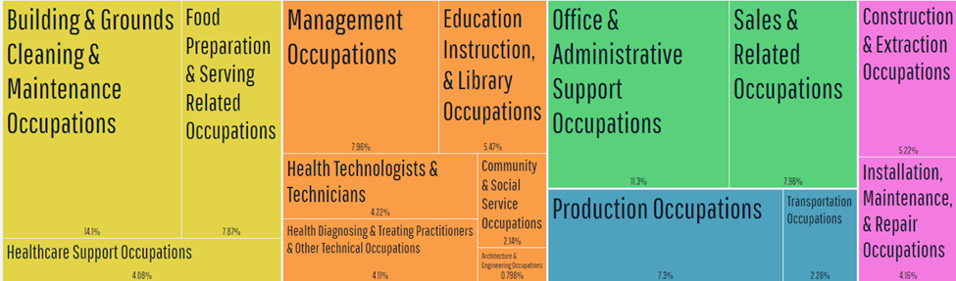
From 2021 to 2022, employment in Moundsville, WV grew at a rate of 6.53%, from 3.29k employees to 3.51k employees. The most common job groups, by number of people living in Moundsville, WV, are Building & Grounds Cleaning & Maintenance Occupations (495 people), Office & Administrative Support Occupations (396 people), and Sales & Related Occupations (280 people).
Employment

Some of the top Employers in Marshall County (in no particular order):

• Appalachian Power (Formerly American Electric Power and Ohio Power Company)
• Marshall County Board of Education
• American Consolidated Natural Resources-Marshall County Mine
• WVU-Reynolds Memorial Hospital
• West Lake Energy (Formerly Axial, PPG Industries)
• Wal-Mart Associates, Inc.
• Williams Energy
- Mull Industries
- Warren Distribution
- Techno Cap
- EQT-Equitable Resources Inc.
- Covestro (Formerly Bayer)
(Source: West Virginia Department of Commerce)

While we are losing some businesses, the City of Moundsville and the Marshall County Chamber of Commerce is also welcoming new businesses. The city is actively improving their welcoming strategies for new businesses and should continue to do so looking at commercial friendly practices and policies moving forward.



Median Household Income
According to the Census Bureau’s “2008-2012 American Community Survey 5-Year Estimates,” the median household income for West Virginia was $40,400, while the median household income for the City of Moundsville was $33,694, placing the City 17% below the state average. The median household income for Marshall County was close to the state’s median household income at $40,288. According to the graphics on page 10 of this document, both the West Virginia and Moundsville household income averages have increased with the average household income for West Virginia being $55,217 and Moundsville’s at $46,070.

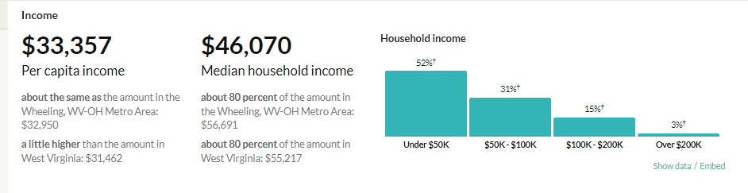
Housing Characteristics

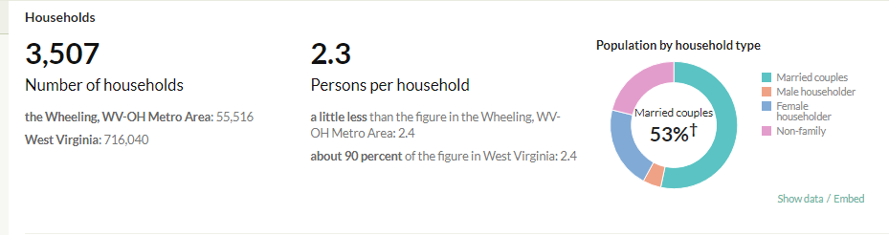
Occupied/Vacant
According to the United States Census, in 1990, there were 4,618 housing units in Moundsville,
with 92% of those housing units occupied and 7.8% vacant. Between 1990 and 2000, the
number of housing units decreased slightly, while the percent occupied (92%) stayed roughly
the same. Even though Moundsville’s housing vacancy rate increased significantly between 2000 and 2010, it remained lower than national and state levels. More recent data shows a significant housing need in Moundsville that aligns with the community feedback obtained from the surveys and the public hearings. Citizens of the City of Moundsville stated that housing is the greatest area of concern for them. Adequacy and availability of affordable housing is their greatest concern.

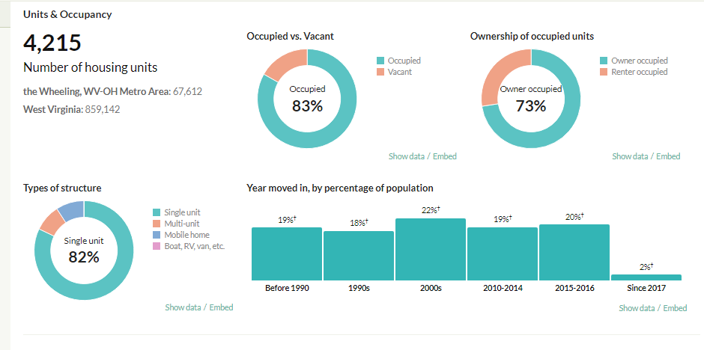
Vacant and occupied housing numbers have changed significantly in recent years. The census data shows a noteworthy decrease in number of housing units available as well as a substantial increase in the percent of vacant units. The percent of vacant units has risen with 16% of units now vacant. The city has made much progress in identifying the uninhabitable vacant units and addressing citizen concerns with dilapidated housing and removing those dangers within city limits. The newly passed and recently enforced Rental Registry Ordinance for the City of Moundsville allows the city to address some of these concerns.
Home Ownership
According to the 2008-2012 American Community Survey, of the homes classified as “occupied,” 72% were occupied by home owners. The median home value was $73,700. These numbers have changed significantly in recent years but are still average for West Virginia.
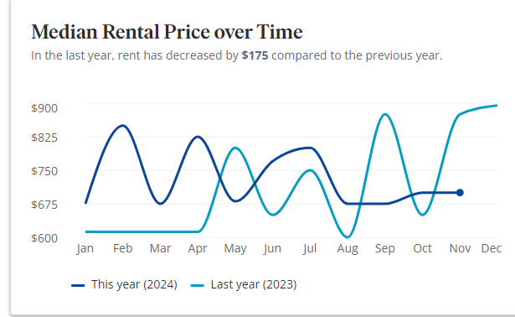
Moundsville has affordable houses. In April 2024, the median listing home price in Moundsville, WV was $169.5K, trending up 9.4% year-over-year. The median listing home price per square foot was $132.
The median home value now is $93,300 with 83% of homes occupied by the owner which is well below average for the nation.

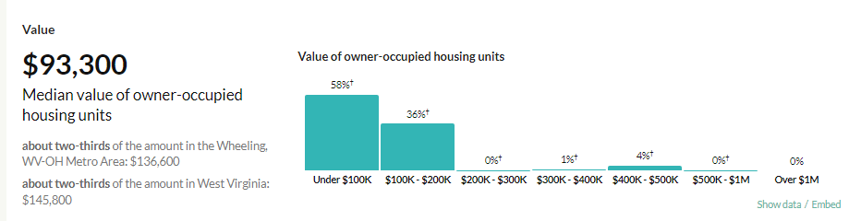

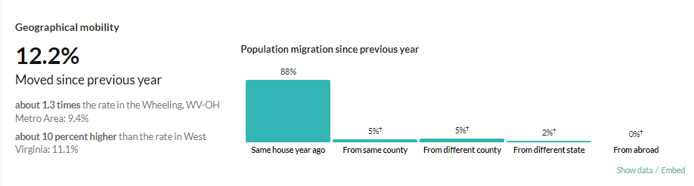
The above graph shows more people staying in their homes for longer in years since 2014 and moving into 2024.

Median monthly rent averaged $436 in 2014 compared to over $700 in 2024; according to Zillow.com, this is much lower than the national average of $1,350. Forty-three percent (39%) of renters paid more than 30% of their household income in rent in 2014; this trend continues but is a little more in 2024 with renters paying nearly 40% of household income in rent.
Age of Housing
The age of the housing stock is just one indicator of housing condition and value. Census data indicates that the vast majority of houses in Marshall County and Moundsville were built prior to 1980. In fact, a large percentage of houses in both the county and city were built prior to 1940. In Moundsville there were also several structures built between 1950 and 1959 and then later between 1970 and 1979. This means that a very high proportion of Moundsville’s housing stock is 30 years or older with a significant portion being 70 years or older. These statistics are important because when older structures are not properly maintained dilapidation and vacancy become issues as has been the case in Moundsville and a concern for the citizens.

Moundsville has seen an increase in building permit applications and new construction in recent years.
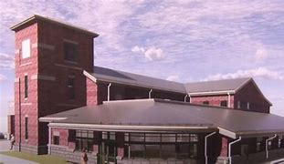
Form of Government
City Government
The City of Moundsville adopted a Council-Manager form of government in 1957. The Council is composed of seven members with one member elected from each of the four wards and three elected at-large by the qualified voters of the city. Members serve four-year terms. Councilmembers are paid a small annual stipend, rendering office holding primarily a volunteer service. The Mayor and Vice Mayor (the Mayor’s alternate) are elected by the Council from among its members and preside over meetings. Terms of service for the Mayor and Vice Mayor are one year and cannot exceed two consecutive terms.
The City Manager position is a full time and compensated position. Councilmembers are
prohibited from taking this position during and within one year of service in elected office. The
City Manager is wholly responsible for the day-to-day operations of the city as the chief
executive officer and head of the administrative side of the city government.
The city has the following officers and department heads: City Clerk, City Attorney, City
Treasurer, Certified Public Accountant, Director of Finance, Chief of Police, Police Court
Judge, Fire Chief, Street Commissioner, Water Superintendent, Sanitary Board
Superintendent, Parks & Recreation Director, and a paid Stormwater Utility Board. All staff
positions are appointed and held based on merit and many require specific professional
certifications and licensure.
There are currently ten (10) full-time employees that work in City Hall and provide services
including, but not limited to employee benefits, municipal court, pension administration,
license and billing, business and occupancy tax administration, and maintenance of municipal
ordinances and records.
The 2013-2014 annual budget for the City of Moundsville totaled just over $9 million with percent allocations identified in the graph on the next page.
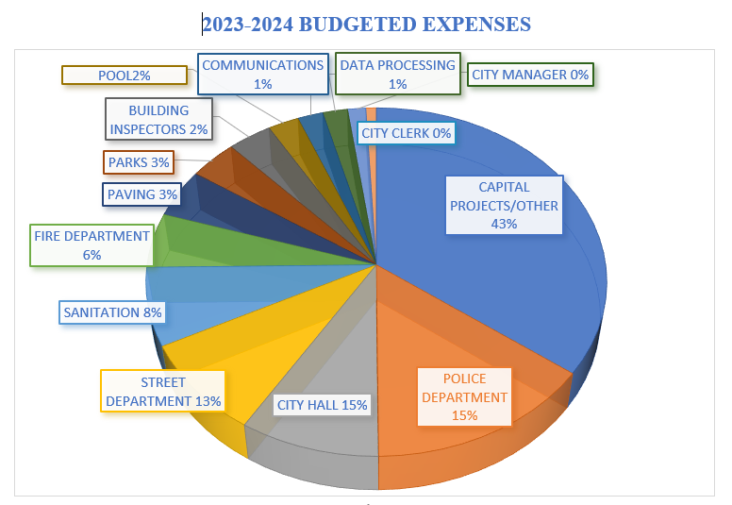
(Source: Rick Healy, City Manager, City of Moundsville Year-End Report 2023.)

Police Department
The Moundsville Police Department consists of 16 full-time officers. They were dispatched to
6,285 calls in 2012 and only 4,794 calls in 2023. The Department currently has a fleet of 16 vehicles with two recent purchases thanks to the City of Moundsville’s 1% sales tax. Updating the fleet is a continued goal; other safety and technology upgrades are also planned. In
addition to their routine duties the police department provides security for festivals and
gatherings in the city and are sometimes hired by private parties and other special events which
they do out of necessity and obligation. The Moundsville Police Department received the “Community Traffic Safety Platinum Award” from AAA for the tenth consecutive year in 2023.
Fire and EMS Services
The city employs 5 full time firefighters. The current vehicular inventory includes 3 pumpers, 1 rescue vehicle, 1 hazmat vehicle, 1 boat, 1 utility vehicle, and the Chief’s car. The Fire Department receives on average 800 calls per year which is 200 more yearly now than in 2014, and the city has mutual aid agreements with Glen Dale, Washington Lands, Fork Ridge, and the Moundsville Volunteer Fire Department. Some of the services provided by the fire department include HAZMAT (with the police department), technical rescues, enforcement of the fire code, fire prevention education, first aid and CPR, and fire investigation.
Parks and Recreation
The City of Moundsville maintains approximately 88 acres of park area within its corporate boundaries. There are thirteen (13) baseball fields, three (3) soccer fields, an indoor community pool, numerous neighborhood and pocket parks, walking/biking trails, and a riverfront park that boasts a stage, picnic shelter, playground, and boat launch.
The parks are overseen by the Parks and Recreation Department Director and Working Foreman. The 2013-2014 budget for Culture and Recreation, which includes parks, for the City of Moundsville was $450,919. In response to input from the community for the 2014 Comprehensive Plan, the city has established an ad hoc committee to find funding sources for a dog park along the riverfront which was completed in 2023. Additionally, work is currently being done to develop a skate park, for which equipment has already been purchased; an outdoor fitness center, one of only two in WV, was added to the amenities available at East End Park with many more attractions, equipment, lighting, and other features installed or upgraded.
There are other recreational facilities within or near Moundsville which are not operated by the
city but which are nonetheless resources to the community. The Marshall County Fairgrounds,
home to the annual county fair which draws large numbers of county residents and tourists is
located on 34 acres within Moundsville. Adjacent to the City of Moundsville to the north is Marshall County’s Grand Vue Park, which boasts over 650 acres of land, complete with a variety of amenities, activities, programs, and lodging for individuals looking for picturesque views and a true outdoor West Virginia experience.
Public Services and Facilities
Public Services and Facilities typically include such things as power utilities, waste
management, and water treatment and supply. These services and their corresponding facilities
are extremely important to the wellbeing of a community. The city provides many of these
services for the benefit of its citizens including some living outside the corporate boundary.
Moundsville operates its own integrated water system, which contains several components,
including a potable water supply, wastewater treatment, and stormwater processing. The
Moundsville Water Department takes its water from wells underneath the Ohio River. They
currently serve over 4,500 customers, connecting over 15,000 people. Moundsville began
upgrading the water treatment plant in 1998 to utilize advanced treatment technology for
control of iron, manganese, disinfection byproducts, taste, odor, color, bacteria and pathogens
(City of Moundsville, 2011). The Water Department has completed a new well installation, two insertion valves on 7th, 8th, and 9th Streets, 65’ of 2” waterline on 9th St. and Juniper Ave., new lines on Henrietta Ave., and done many repairs and upgrades to the systems.
In 2006 after years of permitting and approval, Moundsville started the construction of a new
water treatment plant. The department has done many upgrades since to provide stellar water quality and service to the residents of the City of Moundsville and product for outlying areas. However, capacity remains an issue.
Education
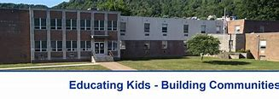 
The Board of Education Office for Marshall County Schools is located right outside Moundsville city limits on 4th Street. Marshall County Schools provide Pre-K through high school education for residents of Marshall County. There are currently eight (8) elementary schools, including one (1) in the city limits (Central) and one (1) right outside the city limits (McNinch Primary). There are three middle schools in the county including Moundsville Middle School. There are also two high schools, neither in Moundsville. John Marshall High School services Moundsville and is located in neighboring Glen Dale. Additionally, the Board of Education has established the Gateway Achievement Center which is located in Moundsville and is designed to meet the needs of students in grades 7-12 that may need special attention and/or a different classroom environment.
According to the West Virginia Department of Education, 4,778 students enrolled in Marshall County Schools in 2013, which has seen a decrease in enrollment for some time. In 2002-2003 the reported enrollment was 5,370, correlating with an 11% decrease in enrollment in 10 years. The Marshall County Board of Education employed 348 teachers (last reported in 2006) and had a pupil/teacher ratio of 14 to 2. Currently, enrollment in Marshall County Schools stands at 4,304 students which is a slight decline from 2014. The student body is made up of 95.5% White, 1% black, 1% non-Hispanic, and 1% Hispanic. Additionally, 2.5% of students are two or more races. Less than 1% are English Language learners. The current pupil/teacher ratio is 12 to 1.
The West Virginia Department of Education (2010-2011) reported a graduation rate of 81.9% for
John Marshall High School which is now up to 95% in 2023. State assessment scores for John Marshall High School were lower than county and state averages in 2014 but are also now commensurate with national averages and 2023 numbers have JMHS outscoring its county and state averages. During the 2010-2011 school year, less than 38% of John Marshall High School students tested at or above mastery in math. The rate for the reading assessment (36.8%) was even lower; however, in 2023 over half our students, 51%, tested above master in reading and writing on the SAT Exam given junior year, but math scores continue to decline at 18%.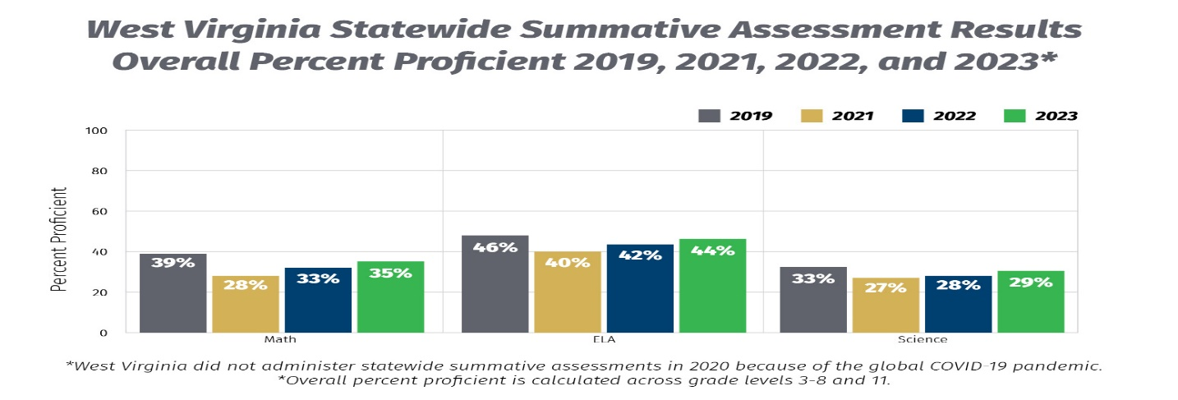
Transportation Characteristics
Two primary roads intersect within the city limits of Moundsville. State Route 2, known as Lafayette Avenue in Moundsville, runs a general North-South direction and connects Moundsville to Wheeling and Interstate 70 to the north, and follows the Ohio River south passing through New Martinsville and Parkersburg all the way down to Huntington. Additionally, the Route 2 spur traverses the Moundsville Bridge into Ohio.
U.S. Route 250 (locally known as Waynesburg Pike) follows a general Northwest to Southeast trajectory. The road enters Moundsville from the east and then combines with Route 2 up through Wheeling, where it splits off and enters Ohio and terminates in Sandusky, Ohio. Going eastward, US 250 passes through Fairmont, then travels south through Elkins, crossing the state line into Virginia. The route terminates in Richmond. Both of these roads connect Moundsville with several metropolitan areas in the region.
There are two local airports fairly close to the city. Marshall County Airport is located a few miles south of Moundsville. The airport has an asphalt runway that is 3301 x 60 ft. There are 8 aircraft that are based on the field and there is an average of 53 aircraft operations per day. Additionally there is the Glen Dale Fokker Field Airport just north of Moundsville. Fokker Field has a turf runway that is 2600 x 100 feet. It is privately owned and has 11 aircraft based on the field. Moundsville is approximately 60 miles away from Pittsburgh International Airport with a drive time of just over an hour.
While there is no train depot in Moundsville, the city does have a working rail line in correction of the Comprehensive Plan of 2014 which stated that a rail line did not exist. Even though the rail line is not used for passenger transportation, it does have an industrial and commercial use.
While there were no ports in Moundsville there is a municipal boat ramp (13th Street Boat Ramp) and dock that can be used for boating activities. This is also being improved to allow for commercial boat usage and as a port on the Ohio River and increased visitor traffic.
The city spent about $1.1 million in fiscal year 2011-2012 on streets and transportation costs. This amount was 19% of the total Moundsville budget; in 2023, only 16% of the total budget was allocated for street and transportation costs.

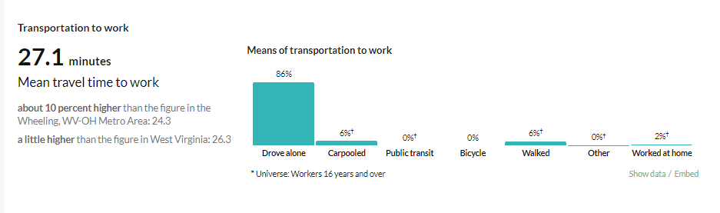
Public Transportation
The city actively worked, in recent years, with the Ohio Valley Regional Transportation Authority (OVRTA) to increase and enhance services within the city, but this endeavor did not make it to a ballot; some citizens of Moundsville are still interested in extending OVRTA coverage and seeing this on the ballot at a future time, and a variety of transportation options are available in the city by appointment through taxi and other services. For now, no public transportation routinely services the City of Moundsville. However, the aforementioned OVRTA services parts of Marshall County, and the Marshall County Senior Citizens Center, Inc. provides transportation for doctor’s appointments and other errands as many times a week as a senior might need. The Senior Citizens Center serves citizens of Moundsville.
Existing Land Use
During the initial comprehensive plan process the community, with the assistance of Professor
Margaret Stout and the West Virginia University Department of Public Administration,
formulated a land use mission “to create a community with a strong sense of history and small
town character, but with diverse contemporary amenities.” With that in mind, many of
Moundsville’s residents, government officials, business stakeholders, and non-profit
organization representatives recognize the need for a more comprehensive approach that can
help them restore their traditional neighborhood fabric and attract businesses back to Uptown, the Jefferson Ave. Historical District, and neighborhood commercial areas. Today, most of Moundsville is single-family residential, especially east of Grant Avenue. However, there are several multi-family developments that are scattered around the city, many under the supervision of the Moundsville Housing Authority. Additionally, two semi-contiguous commercial areas exist, one running along State Route 2 (Lafayette Ave.), where there are a mixture of some big-box retail and small business storefronts. The other area includes the historic commercial downtown district (Uptown) that is located along Jefferson Avenue. These two areas run parallel to each other.
With the closure of the Fostoria Glass Plant, most of the city’s remaining industrial sites are
located along Route 2 in the southern part of the city. Because Moundsville is the county seat
of Marshall County many government facilities, including the courthouse, are found in the
Uptown area. Moundsville is very close to being built out, meaning that very little developable land remains within city limits. Therefore, no rural areas exist within the city, although surrounding portions of Marshall County are rural in nature and might be considered for future
annexation initiatives. Additionally, very little land in Moundsville would be classified as
agricultural land.

Much of the riverfront, within city boundaries, have been left undeveloped. Almost all land
west of Route 2, including the riverfront, and a significant portion east of Route 2, is located
within the Special Flood Hazard Area (AKA the “floodplain”). The city should consider what
types of future development and redevelopment in the floodplain, including leaving it
undeveloped, is best.
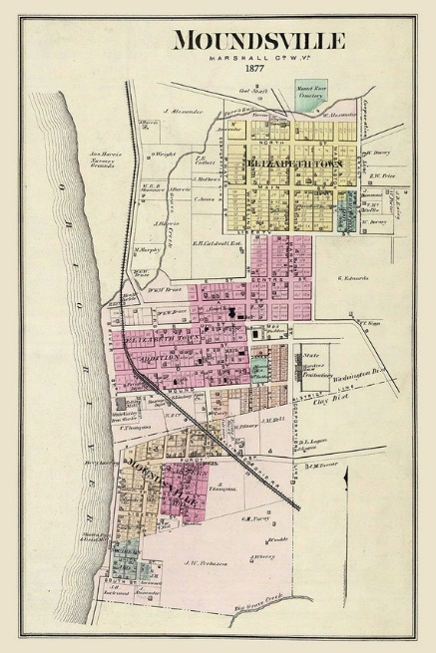
In 1771, English colonists Samuel and James Tomlinson built a cabin at what later became Moundsville, although they did not overwinter, and in fact left for several years after attacks by Native Americans. Elizabethtown, as Tomlinson's community was called, was incorporated in 1830 and would become the county seat upon the creation of Marshall County in 1835. Nearby, the town of Mound City was incorporated in 1832. The two towns combined in 1865.
Moundsville enacted a zoning ordinance in 1972 to regulate land uses within its boundaries.
Periodic updates to the ordinance have been made. The text of the zoning ordinance states
that there are fifteen (15) different zoning districts. However, there is a discrepancy between
the textual component of the zoning ordinance and the official zoning map, particularly in the
number of zoning districts. The zoning ordinance, including the official zoning map, need to be
further updated to be internally consistent. Also in 1972, the city enacted subdivision regulations to control the division and development of land within the city. The ordinance includes standards for streets, lots, easements, signage, trees, public sites and open spaces, and utilities. It has been over forty years since the subdivision regulations were first developed, the city should review and update these provisions to reflect the current environment of land development in Moundsville.
A commercial and historic district in the city was designated in 1995 in the National Register of
Historic Places. This district, which is distinct from the zoning ordinance, is located along
Jefferson Avenue and on 7th Street between Lafayette Ave. and Jefferson Ave. This designation
provides recognition to the community and allows the property owner to apply for matching
funds for restoration among other things.
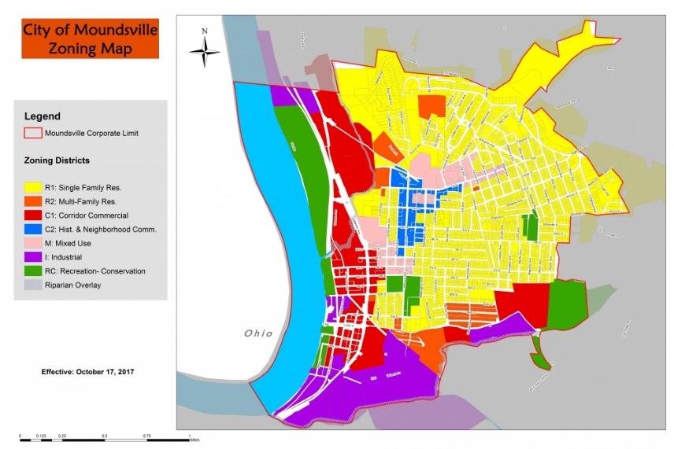
Chapter 3: Needs Assessment
The zoning maps before 2017 did not delineate historical, commercial, and recreational areas as does the current version. The map allows the City Council and its Commissions to accurately make decisions in line with the City of Moundsville’s plan for the future.
The Chapter 3-Needs Assessment lays out the identified critical issues.

Public Participation
It is important to involve the public early in the comprehensive plan process in order for there to
be community buy-in and meaningful public participation. With that in mind, there have been several instances where the public has been encouraged to participate, provide input, and be active participants in the development of the revision of the Moundsville Comprehensive Plan.
The Planning Commission worked towards the completion of a comprehensive plan for 2014
beginning October 2011. In the Fall of 2011, students in the Public Administration Department at
West Virginia University assisted the City in generating a list of stakeholders. During that time
there were several community engagements exercises. From the outset, stakeholders, staff
members, and citizens were invited to identify the city’s vision for the future, the goals, and the
objectives that would be necessary to achieve that vision. In March 2012, an open-ended survey
was distributed through an online survey web link and the Moundsville Daily Echo. A total of 111 surveys were completed and returned. The surveys provided important insight into some of the more pressing issues facing Moundsville. In the Spring of 2012, those stakeholders were contacted and invited to participate in planning activities that would help provide further insight into the major issues that needed to be discussed. Later in the Fall of 2012, the WVU Community Design Team conducted a planning and design charrette to help the community start to develop a list of recommendations. In June 2013, the Planning Commission held an Open House Workshop at the Penitentiary to elicit comments from citizens and conduct a Strengths, Weaknesses, Opportunities, and Threats (SWOT) analysis for the draft comprehensive plan. To prepare for the revisions necessary, the Planning Commission delved into a like process for community involvement. In 2014, the Comprehensive Plan was adopted by the City of Moundsville’s City council. Finally, in the summer of 2024, a like survey was distributed via a link on the city’s website, social media page, paper survey copies available around the city, and the Moundsville Daily Echo to which 140 respondents submitted feedback while less than half a dozen paper surveys were submitted. Two public forums were held to allow people time to discuss their ideas and concerns. The local Media was also in attendance.
Pursuant to Chapter 8A of the West Virginia Code, public input procedures were adopted and
followed throughout the comprehensive plan process. The Planning Commission and the City
Council also followed state code requirements regarding public hearings and notice and
comment periods. Input received during the public meetings and the public hearings can be
found in the Appendices.
Needs Assessment
A comprehensive plan is a community’s vision for the future. By documenting and assessing the
needs of the community upfront, the comprehensive plan can address issues and concerns and recommend realistic strategies to fulfill the community’s vision. The public meetings and other community engagement activities were vital in obtaining feedback from the community.
Critical Issues
The critical issues facing Moundsville have been identified and developed through a series of discussions, meetings, surveys, and research. While there are several issues that need to be addressed, one main area of concern dominated the feedback which was finance and economic development. The two other concerns that made the top three list included housing and infrastructure. These need to be addressed in order for the community to achieve its vision for the future, some specific issues are critical to the short- and long-term well-being of the city. This plan will also address some ancillary factors that affect the three main issues.
Vision Statement and Goals

Vision Statement (City’s Mission Statement)
"To improve our citizen’s quality of life in a positive, productive way and to help educate and move our city and its citizens into the future."

Goal 1: Continue to encourage and create new opportunities for commercial and economic development.
Goal 2: Plan for increased housing needs
Goal 3: Continue to plan for and improve infrastructure opportunities
Goal 4: Properly plan for the natural gas and other industry boom

Governance
In order for Moundsville to move forward, it is imperative that there continues to be professional, ethical, and visionary leadership guiding the city. Being transparent, readily available, and attentive to the public’s needs will help in providing strong and effective leadership. The importance of these leadership qualities transcend elected and executive positions to include department heads and all other paid employees and volunteer board/commission members of the city.
During the Community Conversations exercises facilitated by the WVU-Department of Public
Administration faculty and students the following governance issues were identified. The citizens would also like to see a collaborative attitude and cooperation among organizations in all sectors to develop common goals, develop resources, and complete projects. The results further revealed that the community would like to focus on recruiting youth and women into civic leadership roles and expand participation in citizen advisory boards. Community members want to see invigorated leadership coming from new community sources, particularly younger generations. The community has proven this by electing more female council members and appointing more female commission members; additionally, the city manager reports that transparency in city government has increased through social media and other technologies.
City Officials should also strive to engage the community as much as time and capacity
permit. This engagement should be completed through as many mediums as possible
including social media, frequent municipal website updating, working with schools, public
service announcements, and dedicated times where the public can come and discuss issues
with elected officials and department heads (“Coffee Time”). The City Manager reports more involvement from his office and other departments as they all venture to more fully participate in community activities and in school outreach efforts citing recent, increased guest speakerships.
Land Use
In order to achieve the overall vision and goals established in the comprehensive plan in 2014,
Moundsville’s land use ordinances have been updated to be in compliance with current statutory requirements and with the changing needs of the community. Additionally, the subdivision regulations that were originally developed in 1972 have not been amended since their adoption. The city needs to review and analyze the regulations to see if they still fit the needs of the community, and the Planning Commission has maintained subdivision discussion as part of their ongoing agenda. While subdivision development has been examined and deemed unavailable at this time through the Planning Commission discussions, up-to-date subdivision regulations will help ensure compliance regarding any new development and land use.
Annexation is a tool the city has considered. With annexation, the city could see an increase the amount of Business and Occupation Tax. However, the city also took into account additional costs that might occur with adding annexed land into the city and deemed annexation not plausible at this time due to increased cost and inconvenience for city utilities. By annexing land, the city will increase its geographical size and likely its total population. Annexation could increase the city’s population to over 10,000 people which would allow the city to be reorganized as a Class II City and therefore giving Moundsville additional taxation and financing authority. The city should look into developing the land it already has to accomplish this goal.
Recreational Land Use
Much of the discussion during the comprehensive planning process has been centered on
increasing the recreational opportunities throughout the city. The continued development of
the riverfront park should be a top priority for the city. Multimodal interconnection (e.g.
bicycle lanes, pedestrian and vehicular facilities) between the riverfront park and the rest of the
city, including the historic downtown, needs to be given serious consideration.
The city needs to look at the possibility of working with other area officials to continue
the Moundsville-Glen Dale rail trail northward towards Wheeling, and perhaps from Wheeling to a connection with the Great Allegheny Passage Trail in Pennsylvania and the C&O Canal Trail in Maryland, then all the way into Washington, DC. The city’s rail trail could become the western terminus for a several hundred mile, multistate recreational trail.
While the Ohio River provides a great recreational and economic resource for Moundsville
residents, portions of the city are within the Special Flood Hazard Area (Floodplain), especially
along the riverfront. The community should work with FEMA representatives to ensure that the
local Flood Insurance Rate Maps (FIRM) are updated and accurate. The costs and benefits of
developing in the Special Flood Hazard Area should also be considered, which can be done, in
part, by providing citizens with educational materials regarding floodplain management.
In addition to identifying flood-prone areas the West Virginia Code also requires the
identification of any subsidence areas, which is typically associated with Karst areas, topography formed from the dissolution of soluble rocks characterized by features like sinkholes and caves. The West Virginia Geological and Economic Survey (WVGES) published a State Geologic Map which shows all the karst in the state. This map indicates that there is no Karst in the Moundsville area.
Historic Land Use
Much of the charm of Moundsville is derived from its historic and cultural resources. It is
imperative that these resources be maintained, preserved, and made available for the continued
use and enjoyment of both citizens and tourists. The revitalization of the Historic Downtown
Commercial District, as designated by the National Park Service, is a very important first step.
The District has been the historic hub of the community and still operates as the central business
district for the community. While preservation and revitalization of Uptown is important the city
should, at the same time, continue to encourage appropriate commercial development along
State Route 2, and other smaller neighborhood businesses areas. The city does and should continue to utilize its historical resources during community events like Light-Up Night, Jefferson Ave. Fridays, and more.
Housing
While recent census data suggest a continual decrease in population, other factors imply that
there might still be a need for additional housing units in Moundsville. One of the most noticeable influences is the increasing numbers of out-of-state workers coming to the area for employment in the oil and gas business that will likely return in the coming years. Another is the transition to “stay-at-home” guardians and “work-at-home” jobs for families since 2020. With increasing families choosing these options, people can live anywhere, and many are looking for the safety and security of a small town like Moundsville but which also provides a variety of local amenities and opportunities usually associated with big city living along with ease of access to nearby larger cities. Several trailer camps were established within the city and within the county that provide temporary places to keep RVs. The city currently employs an annual permitting process for trailer camps within the city; the city needs to continue to review and revoke, when necessary, these permits as some are being abused within city limits turning these “recreational and temporary” housing options into long-term low-end rentals that allow landlords to curtail the new rental registration process. This type of housing needs addressed.
Another indicator of the need for more housing is that Moundsville’s vacancy rate is significantly lower than either the state or national rates. The city has identified dilapidated/ uninhabitable housing units and is addressing the removal of these which has given officials a better understanding of housing that is available in Moundsville. During this process and as identified as one of the main concerns of the public, the need for additional housing options is needed in the City of Moundsville. The city should identify where new residential development might occur. The city, by way of its ordinances and regulations, should also encourage the development and adaptive reuse of structurally sound buildings increasing the housing stock.
Even though the city has made great strides in this area, the city needs to continue to address the issues of vacant and uninhabitable structures within the city. The city did not demolish any properties in 2013, but has in past years. Many of these structures are not only unsightly but also present health and safety concerns. The city continues to create a local Urban Renewal Authority (URA) whose focus will be to address the issue of abandoned and dilapidated structures in the city. The city needs to review the enabling statutes for URAs in West Virginia, examine what other URAs around the state are doing, and explore creating a URA that can address some of the issues with dilapidated and/or uninhabitable structures in Moundsville. An important first step is for the community to decide whether it has the capacity to fill positions on the Authority and whether the community would be willing to support the initiatives of the Authority.
The city has already established a vacant and uninhabitable buildings registry pursuant to the
West Virginia Code. As of December 2013, there were 111 properties listed in the registry. Staff
has indicated that for the most part the registry has been an effective tool. However, the number
of vacant/dilapidated structures continues to be an area of great concern with Moundsville
residents. One of the main issues is that properties are tied up in a web of family members or
the owners are elderly and are in assisted living facilities and the structures end up sitting vacant and/or uninhabitable due to dilapidation over time. The city has addressed this issue; in 2022, ten structures were demolished; in 2023, fourteen were, and more have been demolished this year.
The Moundsville Housing Authority currently maintains 248 units including Golden Towers,
which is a 7-story high-rise consisting of 93 units for the elderly/disabled. The agency leases
these apartments to low- and moderate-income families. Many of the Authority’s housing units
are aging so there is a concern with dilapidation or increased costs of rehabilitating these
structures. Recent structural updates have been on-going in this area.
Census data shows that Moundsville’s population is older and is likely to continue to age. Many
people want to continue to stay in their homes even if they need assistance with daily functions.
The city may want to encourage accessible housing for people with disabilities through universal
design. According to the National Association of Home Builders “universal design is the design of products and environments to be usable by all people, to the greatest extent possible, without the need for adaptation or specialized design.” The city can encourage the construction or retrofitting of universal design measures that conform with the building code. The city should also provide educational materials to those unaware of the benefits of universal design.
The city can also become involved in programs or projects such as the West Virginia Housing
Development Fund’s Demolition Program and Change, Inc.’s Weatherization Assistance
program. These programs can assist the city and its citizens address vacant and uninhabitable
structures in different ways.
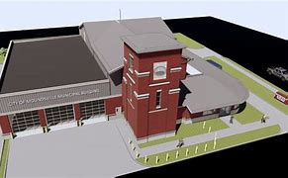

Economic Development
Changes in the national and local economy, including the loss of traditional manufacturing jobs, have had lasting impacts on the social, economic, and physical characteristics of the city. During the last 50 years, the community has seen a 25% decline in population due in part to the closure of several places of employment. The city should seek to bring in new industry and to encourage the revitalization of vacant storefronts. The oil and gas industry was able to temporarily contribute to economic development and growth in the city. Several oil and gas operations exist in Marshall County and, as the county seat, Moundsville is well situated to be the hub for any growth stemming from this industry. With recent declines in this industry, Moundsville renewed a focus on tourism and hospitality to replace the revenue from a declining oil/gas market. The focus on this recreational industry and the additional 1% tax on goods and services used within that sector has been profitable for the City of Moundsville.
In order to facilitate the potential growth from the oil/gas industry, Moundsville explored the development of ancillary services such as additional restaurants and hotel accommodations as outlined in the 2014 plan. The city also continues to facilitate and encourage the development of more and diverse housing options. The construction or rehabilitation of additional businesses and housing units also provides more diverse local employment and housing opportunities to residents. The subdivision discussions and “alternative housing” options discussions had by the Planning Commission should continue and lead to updated ordinance construction and revision that guides the city in the development of alternative housing options.
The city needs to identify sites for future development and industry investment. One area to consider for redevelopment is U.S. Route 250 (First Street) as a mixed use, multi-modal transportation corridor. The city should explore the feasibility of establishing such a corridor. The city should also identify ownership and control of the properties to encourage support and participation. Flexible zoning standards may promote infill development, redevelopment, and adaptive reuse of existing structures. The feasibility of widening the right-of-way to include bicycle lanes along this corridor also should be examined by the city. The ease of use in this area should be a priority including crossing signals for pedestrian traffic.
With the recent closing of several small businesses, a business incubator may facilitate and foster the development of new local businesses and entrepreneurs. The incubator could be established in an empty storefront. The city can ask for assistance from local institutions of higher education such as West Liberty University, where a Center for Entrepreneurship, including a Small and Family Business Program, has already been established.

Encouraging tourism in Moundsville is also an issue and should be a focus of City Council.
The city needs to continue applying to economic development and historic preservation programs such as West Virginia’s On Trac program. If the City of Moundsville successfully completes 2 years in the program, the city would be eligible to become a Main Street program. Participating in the Main Street program provides technical assistance for activities such as downtown design, organizing community facilities, and promoting and improving physical aspects of the town. A number of other grant funding opportunities exist for economic development initiatives.
Transportation and Infrastructure
Transportation
Many of the city’s streets and sidewalks are in need of repair due to age and intensity of use. The city has a Capital Improvement Program that will identify, prioritize, and develop a timetable for the repair of existing streets and sidewalks as well as the construction of any new roads and/or sidewalks. Access to highly-traveled transportation routes, including a major navigable water body, is a great benefit to the city, its residents, and businesses. Therefore, special attention needs to be given to maintaining existing infrastructure and providing new infrastructure for pedestrian, bicycle, and vehicular travel. Historically intermodal transportation was an important part of the way of life in Moundsville. There were streets, roads, rail lines, barge traffic all of which came together in Moundsville and made the city a bustling place for trade and commerce. While the access is still here much of the river traffic has disappeared. Maintaining the current bike and walking trail as well as adding bike lanes to other streets and areas should be a priority.
Convenient options for commercial and industrial truck traffic to get through Moundsville is needed. One option is to reconstruct the upper portion of Jefferson Avenue between 1st Street and the Route 2 merge so that area can accommodate heavy industrial traffic. Another option from the 2014 plan was to construct a 3-way intersection for State Route 2 and U.S. Route 250 by way of a new road extension of 1st Street which has been completed and successfully implemented into the traffic pattern.
Another concern involves access to and from Grand Vue Park. The city needs to identify or construct an appropriate vehicular route to Grand Vue Park which would eliminate some of the cut-through traffic in the Park View neighborhood. This route could be facilitated in part by updating and creating new wayfinding signage. Wayfinding signage can serve a dual purpose, the signage can encourage truck traffic to take certain routes, while at the same time alerting people, especially along Route 2, to various points of interest including the historic downtown commercial district and Grand Vue Park.
While parking in and around the city is not as major a concern in Moundsville as in other places,
parking remains a concern in some areas in the city, including Courthouse Plaza. However, the annex to be built to the courthouse should alleviate some of the parking issues. Areas along Tomlinson Avenue, Center Street, and the lower end of 9th and 10th Streets have also been identified as areas where parking can sometimes be difficult to find.
There are currently no public transportation options for Moundsville residents. During the 2012 general election there was a vote for Moundsville residents as to whether they wanted to establish a public transit system through the Ohio Valley/Eastern Ohio Regional Transportation Authority (OVRTA). The vote lost as the cost was going to be close to $100,000 per year which would be paid by city residents through Marshall County property taxes. Prior to the election there was a 3-month free trial with OVRTA, which provided transit services for Moundsville and surrounding areas. This trial process was completed again in 2024, but City Council voted not to include this option in the general election process for community voting.
Infrastructure
One issue identified by citizens in 2014 stems from confusion on how to use the new online payment system for water service. The new payment system, which is optional, stirred complaints and confusion, and steps were taken to help citizens utilize this method of payment. A call to update the city website was included in the 2014 plan, and it is continuously being updated at this time.
Since 1994, there has been an ordinance in place that requires residents to recycle metals, glass,
plastics, and newspapers. The city should look at the costs and benefits of implementing the
ordinance and providing recycling services to its citizens. Since the 2014 plan, the city has implemented recycling in the city for paper, glass, and soft plastics; more progress needs made to include metals in this service in compliance with that ordinance.
In 2014, the plan asked the city to examine garbage collection options. To date, the City of Moundsville provides garbage collection to its residents. However, the city should also analyze whether privatizing solid waste management services might permit the City of Moundsville to improve and expand service. Pet waste was also brought up during discussions with citizens. To address litter and pet waste, educational programs could be implemented and pet waste stations could be funded and installed by local residents or businesses to help remedy the problem.

Quality of Life
Through the comprehensive plan process prior to 2014 several issues were identified as they pertain to recreation, cultural resources and overall quality of life. First, citizens wish to better utilize the riverfront area as a recreational and communal space. Next, they would like to see more beautiful and clean public spaces and pedestrian routes. Third, citizens want teens and young adults to have more desirable park amenities and programs. Finally, they would like to see the city explore ways to collaborate with the county and other groups to maximize resources available for parks improvements and recreation programming. Since that time, the City of Moundsville has addressed many of these concerns and made several improvements to multiple areas and parks around the city. One area that still needs attention is for pedestrian routes
Also through the comprehensive plan process prior to 2014, the community discussed that while there are several recreational opportunities in Moundsville such as the Riverfront Park,
the Four Seasons Pool, and numerous baseball and soccer fields, one of the more commonly
cited areas for improvement of the city is increasing amenities, and increasing programming
for teens and young adults, families with young children, and seniors. While it is important to
provide physical activities and amenities, it is also important to encourage the development of
community programs that focus on the arts, crafts, theater, and literature. Since that time, the City Council developed the Arts & Culture Commission which addresses all of these items.

Along with providing the residents of Moundsville enhanced qualify of life, the City of Moundsville should be looking into attracting visitors, businesses, and residents alike; providing them with alterative options like EV charging stations and exploring solar power for city use can attract the visitors, residents, and business to the City of Moundsville.
Chapter 4: Action Plan
Chapter 4-Action Plan includes a list of prioritized goals, a set of objectives, and a list of action steps that have been laid out that aim to specifically address the critical issues in the Needs Assessment.

Vision Statement (City’s Mission Statement)
"To improve our citizen’s quality of life in a positive, productive way and to help educate and move our city and its citizens into the future."

Goal 1: Continue to encourage and create new opportunities for commercial and economic development.
Goal 2: Plan for increased housing needs
Goal 3: Continue to plan for and improve infrastructure opportunities
Goal 4: Properly plan for the natural gas and other industry boom

The Action Plan is a list of prioritized goals, objectives, and action steps that will help guide the community after the comprehensive plan has been adopted. The content in Chapter 4 is derived from the Needs assessment (Chapter 3). There were three (3) areas of concern that were identified throughout the comprehensive plan process, they included:
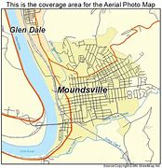
- Financial/Economic Development
- Housing
- Infrastructure

The Action Plan is broken down into goals, objectives, and action steps.

Goals are general
guidelines that are broad, aspirational, and pertain to the overall future development of the
community (Example- “Make the community safer”).

Objectives are more specific, concrete, and are measurable (Example- “Lower the crime rate each year for the next five years”).

Action steps are even more specific and provide specific actions to be taken to achieve the
overarching goals and objectives (Example- “Increase the number of officers assigned to each
beat”).
An implementation matrix is also included at the end of Chapter 4. The matrix includes a list of
the parties responsible for certain action steps, any potential partners, potential funding
sources, and whether a specific action step is a low, moderate, or high priority.

2014 Comprehensive Plan Progress

The City of Moundsville had mixed results from the implementation of the Comprehensive Plan from 2014. The goals and objectives from the former Comprehensive Plan for the City of Moundsville were clearly written; however, other issues existed that blocked progress.

Lack of implementation of the plan had several components:
- Lack of authority by stakeholders.
- Lack of clear responsibility for stakeholders.
- Too many goals.
- Too many objectives.
- Too many action steps.
- Vague or ambiguous goals, objectives, and action steps.

In an effort to enhance the possibility of plan completion by 2034 when a new update or revision will be required, simplification of all the above will be the endeavor of this committee.

Instead of six goals, this plan will have three. Instead of multiple objectives, this plan will provide three or fewer objectives per goal. Instead of multiple and multi-step action steps, we will keep the action steps minimal and highlight responsible parties. Stakeholders will be tagged in each objective as well. Historically, goals with two objectives worked best.

2014 Goal Updates

Goal #1: Develop land use implementation strategies to reflect any change in the community’s needs.
Objective #1: Review and update the zoning ordinance. COMPLETED.
Objective #2: Review and update subdivision regulations. OPEN.
Objective #3: Continue to develop the Riverfront Park. IN PROGRESS.
Objective #4: Explore the possibility of annexation. OPEN.

Goal #2: Remove or rehabilitate dilapidated structures and facilitate the development of new housing options.
Objective #1: New housing construction for rentals and home ownership. OPEN.
Objective #2: Possibility of creating a local Urban Renewal Authority (URA). IN PROGRESS.
Objective #3: Reduce the number of vacant and uninhabitable structures. COMPLETED & ON GOING.

Goal #3: Encourage and create new opportunities for commercial and economic development.
Objectives #1-4. OPEN.

Goal #4: Identify and mitigate various transportation concerns.
Objective #1: Advocate for truck traffic along designated routes. OPEN.
Objective #2: Improve city streets and sidewalks. COMPLETED.
Objective #3: Wayfinding signage and traffic patterns. OPEN.

GOAL #5: Property plan for the natural gas industry boom.
Objectives #1-2: COMPLETED.

Goal #6: Increase recreational amenities and programming for citizens.
Objectives #1-2: COMPLETED.

2024 Goals
Goal 1: Promote Financial and Economic Development within the City of Moundsville.
Objective 1- Continue to develop Route 2 (Lafayette Ave.) as a commercial corridor with well-managed traffic flow.
Action Step 1- Work with the appropriate authorities to plan a desirable access interval at the Walmart exit on Route 2 that will attract new business in the old Elby’s Plaza (formerly Joe’s Auto).

Action Step 2–Provide wayfinding signage on Route 2 for amenities and recreational activities in the City of Moundsville that will enhance visitor experiences.
Action Step 3- Provide safe pedestrian and bicycle lanes and crossings as appropriate on Route 2.

Action Step 4-Provide electric charging stations near Route 2 with wayfinding signage.

Responsible Parties: City Council, City Manager, Street Department, and Division of Highways
Objective 2- Partner with organizations to further local economic development initiatives.
Action Step 1- Work more with the Marshall County Convention and Visitors Bureau to enhance community involvement and awareness.
Action Step 2–Use federal, state, regional, and local economic development funding programs.
Action Step 3- Establish a business incubator in coordination with local universities.

Responsible Parties: City Council, City Manager, Chamber of Commerce, MCCVB

Goal 2: Plan for Housing Options for the Residents of the City of Moundsville.
Objective 1- Update the subdivision ordinance.
Action Step 1- Plan for “alternative housing” options in and out of subdivisions.
Action Step 2–Review and monitor recreational trailer areas for compliance.
Action Step 3- Plan for trailer and manufactured homes areas.
Action Step 4- Restrict manufactured homes without block foundations to designated areas.

Responsible Parties: City Council, Planning Commission, Building Inspectors’ Office

Objective 2- Continue Implementing the Local Urban Renewal Authority (URA)
Action Step 1- Continue to view the scope of projects that other URAs around the state are doing to get a sense of how an URA in Moundsville will be beneficial to the community.
Action Step 2- Maintain the URA over time.
Action Step 3- Since the URA’s primary purpose would be to focus on the redevelopment of blighted and slum areas, the URA would be tasked with creating a plan for those areas.

Responsible Parties: City Council, Moundsville Building Commission, City of Moundsville Housing Authority, City Manager, Building Inspectors, Various Department Heads, the Future Land Reuse Agency Department Director

Goal 3: Plan for the Update of Various Infrastructure in the City of Moundsville.
Objective 1- Identify and mitigate various transportation concerns.
Action Step 1- Plan for Capitol Improvement funding over time for road resurfacing/repairs.
Action Step 2–Plan with the WV DOH to paint lines to restrict or allow right turning lanes at various intersections with and/or without lights.
Action Step 3- Monitor bridge structures within the city and plan for rehabilitation.
Action Step 4- Plan for grant or other funding to help residents improve and maintain sidewalks.

Responsible Parties: City Council, City Manager, Traffic/Street Departments, WVDOH
Objective 2- Identify and mitigate water/sewage/stormwater services to the City of Moundsville.
Action Step 1- Continue to repair, maintain, and monitor water service and lines in the city as needed to provide a constant, quality, continuum of water service to the City of Moundsville.
Action Step 2– Continue to repair, maintain, and monitor sewage service and lines in the city as needed to provide a constant, quality, continuum of water service to the City of Moundsville.
Action Step 3- Continue to repair, maintain, and monitor storm water/drainage service and lines in the city as needed to provide a constant, quality, continuum of water service to the City of Moundsville.
Action Step 4- Plan to work with the state and plan funding to continually upgrade and maintain these services.
Responsible Parties: City Council, City Manager, Water, Sewage, Storm Water Dept. Heads
SOURCES
In No Particular Order.

The Community Overview was summarized from the following sources:

◻ City of Moundsville Comprehensive Plan 2030 Draft
◻ United States Census Bureau American Fact finder
◻ United States Census Bureau American Community Surveys
◻ Grave Creek Mound Archeological Complex, West Virginia Division of Culture
and History (museum exhibits)
◻ West Virginia Department of Commerce, Employment Statistics

Additional Resources used to provide facts and data for inclusion in the 2024 Comprehensive Plan Revision of the 2014 City of Moundsville Comprehensive Plan

2014 City of Moundsville Comprehensive Plan
2023 City of Moundsville Year End Report
https://www.census.gov
https://www.census.gov/programs-surveys/decennial-census/decade/2020/2020-census-main.html
https://censusreporter.org/profiles/16000US5456020-moundsville-wv/
https://www.neighborhoodscout.com/wv/moundsville/real-estate

https://archive.org/details/historicalcollec00mars/page/20/mode/2up

Google Images

APPENDICES ATTACHED

Appendix A: Public Participation Survey (On-Line & Paper Copy)
The results of the online survey and collated copy of paper survey results is attached.

Appendix B: Public Input SWOT Analysis Results

Appendix C: Stakeholder Advisory List

Appendix D: Commission Members List

Appendix E: Ten Year Plan for the City of Moundsville Comprehensive Plan Monitoring

Appendix F&G: Progress Monitoring Form
APPENDIX A
2024 COMPREHENSIVE PLAN SURVEY RESULTS FOR THE CITY OF MOUNDSVILLE
Digital Survey Synopsis:
The digital survey was presented by the commission to the citizens of Moundsville on surveymonkey.com. The link to the survey was shared on social media, the city’s website, and on public notices.
The survey was multiple choice with 10 total questions covering the main required components of the plan.
142 citizens responded to the survey.
Respondents skipped 14 questions in total.
The results show a need for open ended questions on the next survey, so respondents can fill in their own answers to potentially obtain additional information from citizens; however, two public hearings were held for citizens to share their ideas and concerns in-person with the commission, and no new information was presented.
In summary:
According to survey respondents, the biggest challenge the city faces is finance and economic development with housing and infrastructure close behind. With finance and economic development, survey respondents say commercial land use is one of their top priorities. With housing, the survey shows citizens are most concerned about affordability and taking care of dilapidated properties that are deteriorating our neighborhoods in the City of Moundsville. With regards to infrastructure, the citizens of the City of Moundsville worry about road paving, areas for new construction, and recreational areas being monitored and updated. The survey shows that most people use social media to get information about city events and services. The survey also shows that respondents are split right down the middle on the need for public transportation within the City of Moundsville. In general, the public is satisfied with public works, emergency services, and the City of Moundsville as a whole.
Paper Survey Synopsis:
Results from the handful of paper surveys returned to the city align with the results of the digital survey with a shout out to our City of Moundsville Police Chief, Mr. Mitchel for his “extraordinary” service and a notation for upper- and middle-class housing options needing to become a priority for the city.
APPENDIX B
SWOT ANALYSIS OF PUBLIC INPUT
IN ORDER OF PRIORITY BY CITIZEN SURVEYS

STRENGTHS
Emergency Management
City Safety Officials
Police Department
Fire Department
Emergency Response Plans
Public Works
Street Department
Utilities
Services
Parks and Recreation
Ongoing
City Government
Transparency
Engagement
Communication
Social Media/Website

THREATS
Flooding
Aging Storm Water Systems Aging Infrastructure

WEAKNESSES
Economic Development
Commercial
Industrial
Small Business
Housing
Cost
Availability
Variety
Dilapidation
Infrastructure (While Improving)
Roads
Sidewalks
Water lines
Sewer lines
Bridges
Pedestrian Traffic
Bicycle Traffic

OPPORTUNITIES
Arts & Culture
Family Activities
Coordination
Transportation
OVRTA
Bicycling
Water Crafts
Pedestrian Traffic
Recreation
River Activities
Park Upgrades

APPENDIX C

STAKEHOLDERS LIST

CITY MANAGEMENT
Rick Healy
City Manager
304-845-6300
rhealy@cityofmoundsville.com

Sondra Hewitt
City Clerk
304-845-3394
shewitt@cityofmoundsville.com

Karen Ankrom
Finance Director
304-845-3394
kankrom@cityofmoundsville.com

Sara Jasenec
Administrative Secretary
304-845-6300
sjasenec@cityofmoundsville.com

Joe Richmond
Senior Building Inspector
304-830-1874
joerichmond@cityofmoundsville.com

Tom Mitchell
Police Chief
304-559-4245
tmitchell@cityofmoundsville.com

Gary Brandon
Fire Chief
304-639-7745
gbrandon@cityofmoundsville.com

Frank Stocklask
Former-Public works Director
304-650-6923
fstocklask@gmail.com

John White
Recreation Director
304-830-1105
jwhite@cityofmoundsville.com

Brock Castilow
Superintendent-Sanitary Department
304-830-1224
bcastilow@cityofmoundsville.com

Terry Roberts
Superintendent-Water Department
304-280-3725
Troberts.water@aol.com
CITY GOVERNMENT
Tom White
City Attorney
304-845-7008
twhite@white-law.com

Sara Wood-Shaw
Mayor
304-639-6088
swood@cityofmoundsville.com

David Wood
Vice-Mayor
304-650-6611
dwood@cityofmoundsville.com

Ginger DeWitt
Council Person
304-280-2316
gdewitt@cityofmoundsville.com

Judy Hunt
Council Person-Ending 2024
304-639-7111
jhunt@cityofmoundsville.com

Eugene Saunders
Council Person
304-559-7917
bigu11@yahoo.com

Randy Chamberlain
Council Person
304-551-2804
rchangerlain@cityofmoundsville.com

Brianna Hickman
Council Person-Ending 2024
304-709-3511
Brianna.n.hickman@gmail.com

New City Council as of 2025

Don DeWitt
Council Person
304-280-2316
ddewitt@cityofmoundsville.com

Dennis “Denny” Hall
Council Person
dhall@cityofmoundsville.com

APPENDIX D

PLANNING COMMISSION MEMBERS LIST

Josie Mentzer
Chairperson
304-491-9586
wvcjmentzer@gmail.com

David Bougher
Vice Chairperson
304-639-2200
bougher51d@gmail.com

Lacey Williams
Secretary
304-845-3394
lwilliams@cityofmoundsville.com

Joe Richmond
Senior Building Inspector
304-830-1874
joerichmond@cityofmoundsville.com

Brianna Hickman
Council Person (2024)
304-709-3511
brianna.n.hickman@gmail.com

Peter Kurelac
Attorney
304-244-0110
wvlawyer4u@gmail.com
John Icard
Member
304-845-1387

Thomas Berry
Member
614-535-6682
twb404@outlook.com
William McConnell
Member
304-845-4318

Jane Klug
Member
304-845-3453

Todd Morris
Member
304-312-3871

Tabitha Kineer
Member
304-559-3494

Cody Cumpston
Member
304-312-8425

APPENDIX E

TEN YEAR PLAN FOR THE CITY OF MOUNDSVILLE PLANNING COMMISSION

The Planning Commission shall meet each January (and June as needed) to record progress on the Goals from the prior year. If progress is not being made, the Planning Commission shall contact stakeholders and reconvene at their discretion.

JANUARY 2025---Has the 2024 Revision of the 2014 City of Moundsville Comprehensive
Plan been adopted?
If not, resume monthly meetings to complete.
If so, meet June 2025 to make a record of Objective Progress.

JANUARY 2026-2030-------YEARLY
Record Objective Progress.
Contact Stakeholders for updates.
Share Progress and Plan for 2026-2031 Action Steps with City Council.

JANUARY 2031-------Record Objective Progress.
Contact Stakeholders for updates.
Share Progress and Plan for 2031 Action Steps.
Request City Manager/City Council for 2032-2034 Budget allotment
for Preparing the 2034 Revision of the Comprehensive Plan.

JANUARY 2032--------Record Objective Progress.
Contact Stakeholders for updates.
Share Progress and Plan for 2032 Action Steps.
Request City Manager/City Council for 2032-2034 Budget allotment
for Preparing the 2034 Revision of the Comprehensive Plan.

2033---Collect data reviewing the 2024 City of Moundsville Revision of the Comprehensive Plan. Hold two public hearings. Analyze public input from paper/online surveys. SWOT Analysis. Redistribute the 2024 City of Moundsville Comprehensive Plan. Distribute the 2032 City of Moundsville’s End of Year Reports. Write the Comprehensive Plan.

2034---Re-Write, Finalize, and Submit the 2034 Revision of the 2024 Revision of the Adopted 2014 City of Moundsville Comprehensive Plan meeting monthly beginning in January until ready to submit with a June Deadline.

APPENDIX F
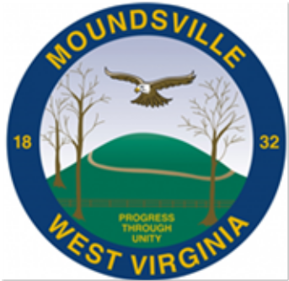

PROGRESS MONITORING DATA SHEET

The planning commission shall review each goal of the City of Moundsville’s
Comprehensive Plan YEARLY to determine progress and maintain communication
with the residents, community stakeholders, and responsible parties.

GOALS, Objectives, and action steps. | SOURCES | CONCERNS
Financial Economic Development
Develop Route 2  As a  Commercial  corridor
  Access interval plan on Route 2 at Walmart for other plaza
  Wayfinding signage on Route 2 for amenities
  Pedestrian and bike lanes and crossings
  EV Charging Stations with Wayfinding signage
Partner with organizations for economic development
  Improve Visitors Bureau Visibility
  Continue to utilize economic develop funding programs
  Establish business incubator

Plan for Housing
Update subdivision ordinance
  Plan for alternative housing options
  Review and monitor recreational trailer areas
  Plan for trailer and manufactures home areas and rules
  Address manufactured homes with block foundations
Explore creating URA
  Continue to review other URAs
  Monitor the URA
  Plan for blighted areas

Plan for updating Infrastructure
Identify & mitigate transportation concerns
  Continue planning long-term capitol improvement funding
  Plan w/ WV DOH painting
  Monitor Bridge Structures
  Plan grant funding for helping residents with sidewalks
Identify & mitigate infrastructure
  Monitor water service lines
  Monitor sewage service lines
  Monitor storm water/drainage
  Plan future funding

APPENDIX G

CITY OF MOUNDSVILLE
COMPREHENSIVE PLAN UPDATES

The planning commission shall review each section of the City of Moundsville’s
Comprehensive Plan YEARLY to determine progress and maintain communication
with the residents, community stakeholders, and responsible parties.

A comprehensive plan must contain the following components:

· Land use:

· Housing :

· Transportation:

· Infrastructure :

· Public Services :

· Recreation :

· Economic development :

· Community design :

· Preferred development areas :

· Renewal and/or redevelopment :

· Financing :

· Historic preservation:

Other:

